Cascading Nature of CSS
Definition:
The Cascading Nature of CSS refers to the way multiple CSS rules are applied to an HTML element when there are conflicts between styles.
The term “cascade” means that styles “fall” from multiple sources and the browser decides which one takes priority.
Order of Priority (Cascade Order)
When multiple rules target the same element, the browser follows three main principles to decide which rule wins:
1. Importance
CSS allows you to mark a style as !important.
This has the highest priority (except for inline styles with !important).

p {
color: blue !important;
}
p {
color: red;
}
<p>Paragraph</p>
The paragraph will be blue because of !important.

2. Specificity
Specificity determines which rule is more targeted to the element.
It is calculated based on the type of selector.
Selector Type | Example | Weight
Inline styles | <p style="color:red"> | 1000
ID selectors | #title | 100
Class, pseudo-class, attribute selectors | .main, :hover, [type="text"] | 10
Element selectors | div, p, h1 | 1
Universal selector | * | 0

#title { color: red; } /* specificity = 100 */
p.title { color: blue; } /* specificity = 11 */
p { color: green; } /* specificity = 1 */

The element with id="title" will be red.

3. Source Order (Last Rule Wins)
If two rules have equal specificity, the last one defined in the CSS file takes effect.
p { color: red; }
p { color: green; }
The paragraph will be green (the last rule).

Sibling Selectors
Sibling selectors are used to select elements that share the same parent (i.e., are siblings in the DOM).
There are two types of sibling selectors in CSS:
Adjacent Sibling Selector (+)
The adjacent sibling selector (+) selects an element that is immediately after another element.
See example: <p></p><h1></h1><h2></h2>
General Sibling Selector (~)
The general sibling selector (~) selects all elements that are after a specified element — not just the first one.

Advanced CSSselectors
1 .Attribute Selectors
Example 1: [attribute] — Select elements having a specific attribute
Example 2: [attribute="value"] — Exact match
Example 3: [attribute^="value"] — Starts with
Example 4: [attribute$="value"] — Ends with
Example 5: [attribute*="value"] — Contains substring

2. Pseudo-Classes
Example 6: :hover — When mouse is over element
Example 7: :focus — When element is focused
Example 8: :nth-child(n) — Selects specific child
Example 9: :nth-child(odd) and :nth-child(even)
Example 10: :not() — Exclude elements
3.Pseudo Elements
Example 11: ::before and ::after
Example 12: ::first-letter
Example 13: ::selection
4. Combinator Selectors
Example 14: Child Selector (>)
Example 15: Descendant Selector (space )
5. Functional and modern selectors
Example 18: :is() — Combine selectors
Example 19: :where() — Like :is() but zero specificity
Example 20: :has() — Parent selector (powerful!)

CSS variables
CSS Variables are custom values defined by you and reused throughout your stylesheet.
They make your CSS:
- Easier to maintain
- Easier to update (change once → updates everywhere)
- More consistent across your design

--variable-name: value; //declaring
property: var(--variable-name); ///this is how using

The :root Selector
:root represents the top-level element of the document (same as <html>).
Using it to declare variables makes them global and accessible anywhere in the CSS.
:root {
--main-bg: #222;
--font-size: 18px;
}

Fallback Values
If a variable isn’t defined, you can provide a default fallback:
h1 {
color: var(--heading-color, black);
}
If --heading-color isn’t defined, it defaults to black.

Grid and Flex Layout
CSS flexbox and grid are two different layout models optimized for user interface design.
Flexbox (also known as flexible box layout) deals with one-dimensional layouts, where you can lay out and align elements horizontally or vertically.
Grid (also known as grid layout) goes a step further and allows you to build two-dimensional layouts, where you can lay out and align elements horizontally and vertically.
Flex
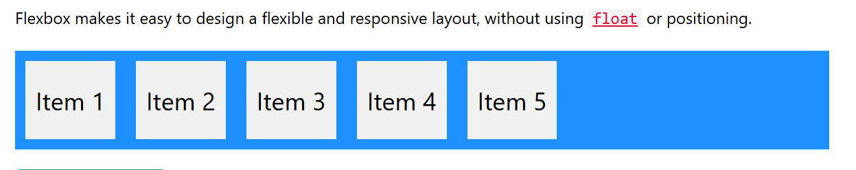
CSS Flexbox Components
A flexbox always consists of:
- A Flex Container - The parent (container) element, where the display property is set to flex or inline-flex
- One or more Flex Items - The direct children of the flex container automatically becomes flex items

CSS Flex Container Properties
The flex container element can have the following properties:
- display - Must be set to flex or inline-flex
- flex-direction - Sets the display-direction of flex items
- flex-wrap - Specifies whether the flex items should wrap or not
- flex-flow - Shorthand property for flex-direction and flex-wrap
- justify-content - Aligns the flex items when they do not use all available space on the main-axis (horizontally)
- align-items - Aligns the flex items when they do not use all available space on the cross-axis (vertically)
- align-content - Aligns the flex lines when there is extra space in the cross axis and flex items wrap

CSS flex-direction Property
The flex-direction property specifies the display-direction of flex items in the flex container.
This property can have one of the following values:
- row (default) 1 2 3 4
- column1
- 2
- 3
- row-reverse 4 3 2 1
- column-reverse 4
3
2
1
Here, we specify that the normal box "grow factor" is 1 and the larger box is 3. The grow factor specifies how much the flex item grows relative to the rest of the flex items in the flex container.

Grid Layout
The Grid Layout Module offers a grid-based layout system, with rows and columns.
The Grid Layout Module allows developers to easily create complex web layouts.
The Grid Layout Module makes it easy to design a responsive layout structure, without using float or positioning.

Header
Menus | Content
Footer

